Evaluation Report

Key Design Decisions
The code developed for the MOM benchmark is structured in three layers: Java drivers, JNI bindings and MOM interface.
Java Drivers: Despite the “driver” name, the java drivers are actually the top layer of software in the benchmark system and comprise the actual suppliers and consumers of messages. . This code generates logs with raw data containing the results of each run. In this scheme, both the consumers and suppliers become distinct entities which utilize and rely on a standard set of services provided by the lower level MOM products. Hence, the consumer and suppliers become clients to MOM services and this document will consistently refer to them as clients. This layer was implemented by the staff at CBOE.
JNI Bindings: The Java drivers call Java classes implemented in native C++ code written in compliance with JavaSoft’s Java Native Interface specifications (JNI). This layer provided a uniform generic interface to the messaging middleware allowing interchangeable modules for each MOM product to be built and plugged in. This layer was developed by the staff at TRC.
MOM Interface: One module for each MOM product was developed and coded directly to the API for that product. One additional module was developed (nicknamed the NILMOM) which did not code to any MOM product but allowed the upper two layers to be executed at CPU speed with no intervening middleware. This allowed maximum throughput levels to be established for the various tests as needed. This layer was developed by the staff at TRC.

Why JNI was used instead of the vendors’ Java interfaces?
- The use of JNI allowed a uniform native threading model to be established across all MOM products. All products could then be compared on an even footing as far as the effects of native threading on client suppliers and consumers were concerned.
- The use of a consistent native threading model in this layer would allow us to determine whether consumer clients could be built which scaled effectively, according to the number of CPUs available on a particular host.

Description of the native threading model chosen
The essential concept employed in choosing the model was to give each consumer client as many threads as there were CPUs available on the host. All consumers would then be able to divide their threads, and therefore their work, evenly among all CPUs available on the host. This added parallelism should improve performance according to Amdahl’s Law. In the ideal case, the interaction of the threading model with the MOM product would not introduce any further serialization and would not degrade any performance gains from the multiple CPUs. This is the assumption for the NILMOM. In the expected case, however, depending on the amount of serialization introduced by the interaction of each individual MOM product with the threads, the additional CPU power may offer little or no advantage.

Hardware and Software Configuration
The following hardware was used to run the benchmark’s test runs:
- Host machines: See Table 1 below.
- Network Configuration: The test system was connected on a full duplex, switched, 100MB vlan .

System name | LIMBO | CBOE1 | CBOE2 | CBOE3
Hardware | Sun Enterprize 2 | Sun Enterprize 2 | Sun Ultra 5 | Sun Ultra 1
OS | Solaris 2.5.1 | Solaris 2.5.1 | Solaris 2.5.1 | Solaris 2.5.1
Processor | 2 x 168MHz | 2 x 168MHz | 270 MHz | 167 MHz
Memory | 256 MB | 128 MB | 256 MB | 128 MB
NIC | 100 Mb | 100 Mb | 100 Mb | 100 Mb
Hard disk | 4.2 GB | 4.2 GB | 4.2 GB | 4.2 GB
Table 1 MOM Benchmark Hardware Configuration
The following software releases were used in the benchmark’s test runs:
- JDK 1.1.5
- Talarian 4.0
- OrbixTalk 1.2c
- Vitria 3.1
- SparkWorks C++ 4.2

Results Coverage
A number of test scenarios were generated by varying:
- Number of suppliers / consumers
- Location of suppliers / consumers
- Number of suppliers / consumers per machine
- Message size
- Quality of Service
- Number of messages supplied per second
- Run time
The following table contains the generated scenarios:

Message Type | Solaris Suppliers | Solaris Consumers | NT Suppliers | NT Consumers | Intra / InterBox | Event Streams | QoS | Rates | Run Time | Scenario Name
One-to-One
Orders (1Kb) | 1 | 1 |  |  | Intra | 1 | Normal | 5, 10 | 1
Orders (1Kb) | 1 | 1 |  |  | Inter | 1 | Normal | 5, 10 | 1
Orders (1Kb) |  | 1 | 1 |  | Inter | 1 | Normal | 5, 10 | 1
Quotes (50b) | 1 | 1 |  |  | Intra | 1 | Normal | 100, 150, 250, 350, 450, 550, 700, 1024, 2048 | 10
Quotes (50b) | 1 | 1 |  |  | Inter | 1 | Normal | 100, 150, 250, 350, 450, 550, 700, 1024, 2048 | 10
Quotes (50b) |  | 1 | 1 |  | Inter | 1 | Normal | 100, 150, 250, 350, 450, 550, 700, 1024, 2048 | 10
Blocks (8Kb) | 1 | 1 |  |  | Intra | 1 | Normal | 50, 75, 100 | 10
Blocks (8Kb) | 1 | 1 |  |  | Inter | 1 | Normal | 50, 75, 100 | 10
Blocks (8Kb) |  | 1 | 1 |  | Inter | 1 | Normal | 50, 75, 100 | 10
Orders (1Kb) | 1 | 1 |  |  | Inter | 1 | Guaranteed | 5, 10 | 10 | OTO1
Quotes (50b) | 1 | 1 |  |  | Intra | 1 | Guaranteed | 100, 150, 250, 350, 450, 550, 700, 1024, 2048 | 15
Blocks (8Kb) | 1 | 1 |  |  | Inter | 1 | Guaranteed | 50, 75, 100 | 10 | OTO2
One-to-Many
Quotes (50b) | 1 | 1,9 |  |  | Intra (1), Inter (9) |  | Normal | 100, 150, 250, 350, 450, 550, 700, 1024, 2048 | 10 | OTM1
Quotes (50b) | 1 | 25 |  |  | Inter |  | Normal | 100, 150, 250, 350, 450, 550, 700, 1024, 2048 | 10 | OTM2
Quotes (50b) | 1 |  |  | 25 | Inter |  | Normal | 100, 150, 250, 350, 450, 550, 700, 1024, 2048 | 15
Quotes (50b) | 1 |  |  | 50 | Inter |  | Normal | 100, 150, 250, 350, 450, 550, 700, 1024, 2048 | 10 | OTM3
Quotes (50b) | 1 |  |  | 100 | Inter |  | Normal | 100, 150, 250, 350, 450, 550, 700, 1024, 2048 | 15
Quotes (50b) | 1 |  |  | 200 | Inter |  | Normal | 100, 150, 250, 350, 450, 550, 700, 1024, 2048 | 10 | OTM4
Blocks (8Kb) | 1 | 1,9 |  |  | Intra (1), Inter (9) |  | Normal | 50, 75, 100 | 10 | OTM5
Blocks (8Kb) | 1 | 25 |  |  | Inter |  | Normal | 50, 75, 100 | 10 | OTM6
Blocks (8Kb) | 1 |  |  | 25 | Inter |  | Normal | 50, 75, 100 | 15
Blocks (8Kb) | 1 |  |  | 50 | Inter |  | Normal | 50, 75, 100 | 10 | OTM7
Blocks (8Kb) | 1 |  |  | 100 | Inter |  | Normal | 50, 75, 100 | 15
Blocks (8Kb) | 1 |  |  | 200 | Inter |  | Normal | 50, 75, 100 | 10 | OTM8
Some-to-Many
Quotes (50b) | 3 | 1,9 |  | 25 | Intra (1), Inter (9) |  | Normal | 50, 75, 100 (to NT); 100, 150, 250, 350, 450, 550, 700, 1024, 2048 (to Solaris) | 10 | STM1
Quotes (50b) | 3 | 25 |  |  | Inter |  | Normal | 100, 150, 250, 350, 450, 550, 700, 1024, 2048 | 15
Quotes (50b) | 3 |  |  | 25 | Inter |  | Normal | 100, 150, 250, 350, 450, 550, 700, 1024, 2048 | 15
Quotes (50b) | 3 |  |  | 50 | Inter |  | Normal | 100, 150, 250, 350, 450, 550, 700, 1024, 2048 | 15
Quotes (50b) | 3 |  |  | 100 | Inter |  | Normal | 100, 150, 250, 350, 450, 550, 700, 1024, 2048 | 15
Quotes (50b) | 3 |  |  | 200 | Inter |  | Normal | 100, 150, 250, 350, 450, 550, 700, 1024, 2048 | 15
Blocks (8Kb) | 3 | 10 |  |  | Inter |  | Normal | 50, 75, 100 | 10 | STM2
Blocks (8Kb) | 3 | 25 |  |  | Inter |  | Normal | 50, 75, 100 | 10 | STM3
Blocks (8Kb) | 3 |  |  | 25 | Inter |  | Normal | 50, 75, 100 | 15
Blocks (8Kb) | 3 |  |  | 50 | Inter |  | Normal | 50, 75, 100 | 15
Blocks (8Kb) | 3 |  |  | 100 | Inter |  | Normal | 50, 75, 100 | 15
Blocks (8Kb) | 3 |  |  | 200 | Inter |  | Normal | 50, 75, 100 | 15
Many-to-One
Quotes (50b) | 5 | 1 |  |  | Inter |  | Normal | 100, 150, 250, 350, 450, 550, 700, 1024, 2048 | 15
Quotes (50b) | 10 | 1 |  |  | Inter |  | Normal | 100, 150, 250, 350, 450, 550, 700, 1024, 2048 | 10 | MTO1
Quotes (50b) | 15 | 1 |  |  | Inter |  | Normal | 100, 150, 250, 350, 450, 550, 700, 1024, 2048 | 15
Blocks (8Kb) | 5 | 1 |  |  | Inter |  | Normal | 50, 75, 100 | 15
Blocks (8Kb) | 10 | 1 |  |  | Inter |  | Normal | 50, 75, 100 | 10 | MTO2
Blocks (8Kb) | 15 | 1 |  |  | Inter |  | Normal | 50, 75, 100 | 15
Blocks (8Kb) | 5 | 1 |  |  | Inter |  | Guaranteed | 50, 75, 100 | 10
Blocks (8Kb) | 10 | 1 |  |  | Inter |  | Guaranteed | 50, 75, 100 | 10
Blocks (8Kb) | 15 | 1 |  |  | Inter |  | Guaranteed | 50, 75, 100 | 10
Multiple Event Streams Test #1
Orders (1Kb) | 1 | 1 |  |  | Inter |  | Normal | 5, 5, 10, 10 | 10 | MES1 (all 4 streams run concurrently)
Quotes (50b) | 1 | 5 |  | 50 | Inter |  | Normal | 100, 200, 500, 700 | 10
Blocks (8Kb) | 10 | 1 |  |  | Inter |  | Normal | 50, 50, 75, 100 | 10
Orders (1Kb) | 1 | 1 |  |  | Inter |  | Guaranteed | 5, 5, 10, 10 | 10
Multiple Event Streams Test #2
Orders (1Kb) | 1 | 1 |  |  | Inter |  | Normal | 10 | 480 | MES2 (all 4 streams run concurrently)
Quotes (50b) | 1 | 5 |  | 50 | Inter |  | Normal | 200 | 480
Blocks (8Kb) | 10 | 1 |  |  | Inter |  | Normal | 100 | 480
Orders (1Kb) | 1 | 1 |  |  | Inter |  | Guaranteed | 10 | 480
Table 2 MOM Benchmark Scenarios
The goal of these benchmark scenarios was to determine the performance of the MOM products under a variety of realistic conditions.

Selected Scenario Runs
Since running all the scenarios in Table 2 MOM Benchmark Scenarios would have required substantial resources, only the shaded scenarios were selected as the most representative in CBOE’s future environment. The following table shows the status of the selected scenario runs for each product:

Scenario Name | Talarian | MQSeries | Vitria | NeonNet | OrbixTalk
OTO1 | Completed | Cancelled | Completed | Cancelled | Partial
OTO2 | Completed | Cancelled | Completed | Cancelled | Partial
OTM1 | Completed | Cancelled | Partial | Cancelled | Tentatively Cancelled
OTM2 | Completed | Cancelled | Cancelled | Cancelled | Tentatively Cancelled
OTM3 | Partial | Cancelled | Cancelled | Cancelled | Tentatively Cancelled
OTM4 | Partial | Cancelled | Cancelled | Cancelled | Tentatively Cancelled
OTM5 | Completed | Cancelled | Cancelled | Cancelled | Tentatively Cancelled
OTM6 | Completed | Cancelled | Cancelled | Cancelled | Tentatively Cancelled
OTM7 | Partial | Cancelled | Cancelled | Cancelled | Tentatively Cancelled
OTM8 | Partial | Cancelled | Cancelled | Cancelled | Tentatively Cancelled
STM1 | Completed | Cancelled | Cancelled | Cancelled | Tentatively Cancelled
STM2 |  | Cancelled | Cancelled | Cancelled | Tentatively Cancelled
STM3 |  | Cancelled | Cancelled | Cancelled | Tentatively Cancelled
MTO1 |  | Cancelled | Cancelled | Cancelled | Tentatively Cancelled
MTO2 |  | Cancelled | Cancelled | Cancelled | Tentatively Cancelled
MES1 |  | Cancelled | Cancelled | Cancelled | Tentatively Cancelled
MES2 |  | Cancelled | Cancelled | Cancelled | Tentatively Cancelled
Table 3 Status of MOM Benchmark Runs

Benchmark Results
MQSeries was eliminated from consideration on 5/15/98 because of significant drawbacks, specifically, lack of support for the publish & subscribe model.
Vitria was eliminated from further consideration on 6/19/98 because of extremely slow performance and stability problems.
NeonNet was eliminated from further consideration on 6/19/98 because of unavailability of product to TRC staff.
OrbixTalk presented problems with more than one consumer. The consumers for higher order tests disconnected. So far there has been no success on correcting this problem. This problem makes OrbixTalk unsuitable in CBOE’s environment where multiple consumers are commonplace. Another serious problem was the loss of messages at higher rates.
Talarian SmartSockets performed the best of all products examined. There were no real throughput concerns with Talarian’s product, but it did experience stability problems in the higher-order tests. Good responsiveness from Talarian support made it possible to work through or explain most of the connectivity issues. Connectivity issues regarding clients, is adequately explained by the CPU bounded nature of the higher order tests. As more and more clients on the same machine contend for CPU resources, they are not able to consume messages fast enough to keep pace with message suppliers. Eventually, the client message buffer in RTSERVER fills to capacity and RTSERVER disconnects the client. The proper means to deal with this issue in production, is to introduce some form of flow control. A white paper is in our possession from Talarian detailing how flow control can be implemented in SmartSockets.
The outstanding connectivity issue with SmartSockets is the inability of RTSERVERS to maintain proper connectivity amongst themselves during the higher order tests. Specifically, RTMON on different hosts will report different and contradictory connectivity patterns between the RTSERVERS. This issue is not entirely understood, and there has not yet been an explanation from Talarian. However, it is not an entirely mysterious phenomenon. RTSERVERS maintain connectivity between themselves through the use of UDP broadcasts. UDP is a protocol which does not guarantee delivery of packets. It is not unreasonable to suppose that during periods of high network activity, as in the high-order tests, some of the UDP packets do not arrive at their destination. It is not hard to envision a situation where no two RTSERVERs received the same set of broadcast packets. What remains unanswered, is why the RTSERVERs do not re-establish proper connectivity once the network quiets and what the effect on message delivery might be when RTSERVERs do not consistently agree on connectivity patterns.

Comparison of the products.
A quick glance at Table 3 will reveal that a comparison between the products is only possible for the low order tests. The stability problems with two of the products, OrbixTalk and Vitria, made it impossible to obtain results for the higher order tests. Even for Talarian, only partial results for the higher order tests are available because of stability issues.
The following three figures illustrate some of the differences between the products. Figures 1, 2 and 3 chart the performance metrics for test OTO2 between the Talarian, OrbixTalk, and Vitria products. The test OTO2 was configured to send block size information at rates of 50, 75 and 100 messages per second using guaranteed delivery. Of the three products, only Talarian was able to smoothly and consistently keep up with the programmed message rates.

Figure 1 Talarian's Peak Message Rates for OTO2 Scenario 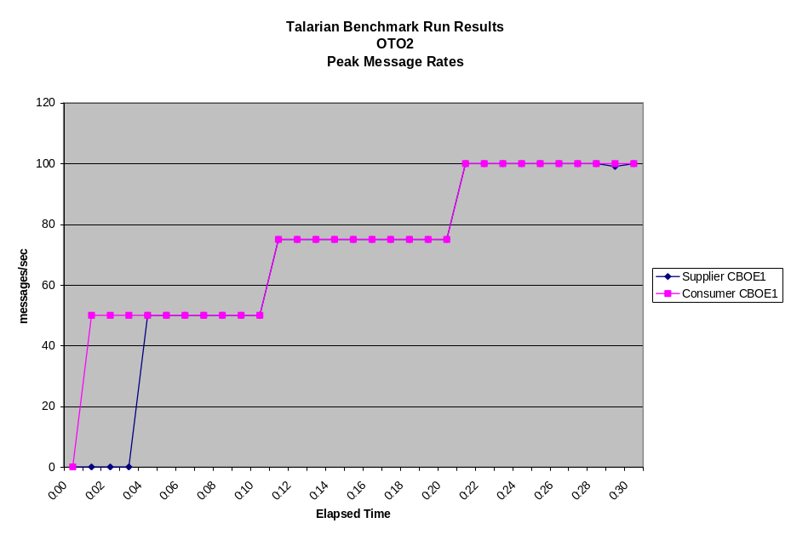

Figure 2 OrbixTalk Peak Message Rates for OTO2 Scenario
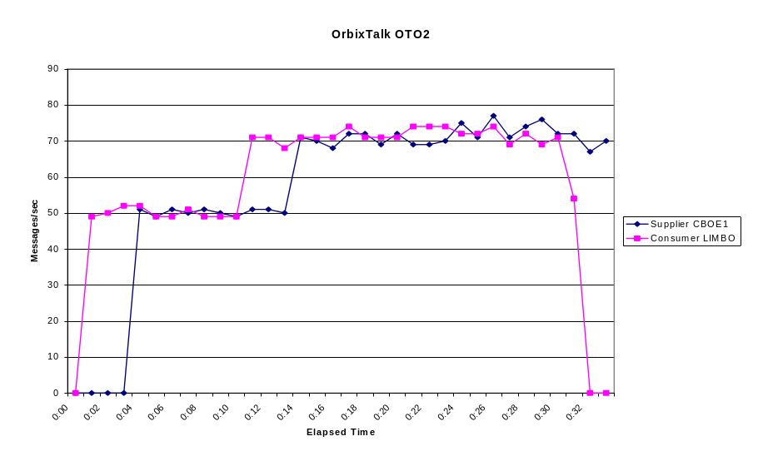
Figure 3 Vitria Peak Message Rates for OTO2 Scenario

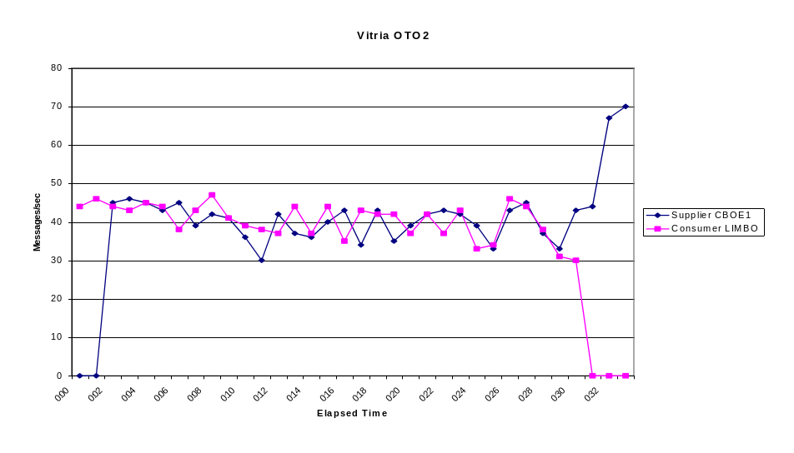
It should be noted that in each of these three figures, the consumer appears to start receiving messages four minutes earlier than the supplier starts sending them. This anomaly is due to a time difference between the hosts.

Figures 4 & 5. NILMOM rates for OTM2 and OTM1
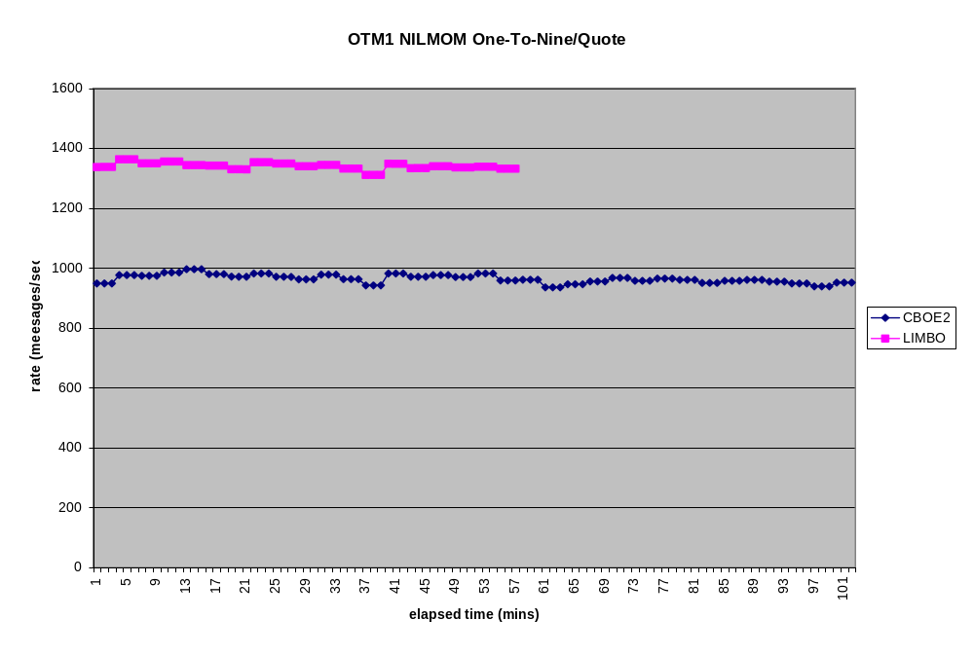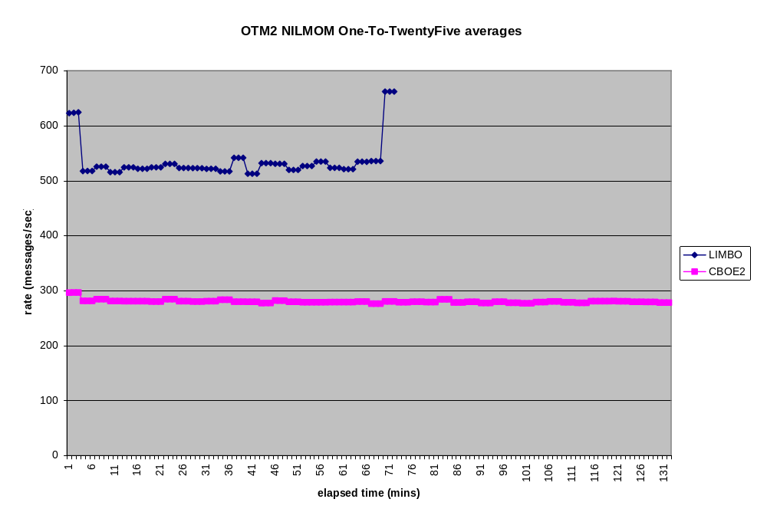

The Scalability Issue
An examination of figures 4 and 5 reveals expected behavior for tests OTM1 and OTM2 for the NILMOM module. This module codes the MOM interface layer, but is mostly vacant. It does not interface to any MOM product and simply allows the tests to be run at CPU speed. No added serialization is introduced into the consumer threads. Under these conditions, you would expect consumers on the dual processor machine Limbo (2 X 168Mhz) to perform better than the consumers on the single processor machine Cboe2 (275 Mhz) because the two thread per consumer model on Limbo can effectively utilize both processors. An inspection of the two graphs for the NILMOM module reveals that this is the case.

When the consumer threads have to interact with the Talarian MOM API, the story changes considerably. Since Talarian is single threaded, it stands to reason that significant serialization must be introduced into the consumer threads when they interact with it. It would be expected, in this case, that consumers would perform worse on the dual processor machine Limbo than on the single processor Cboe2. This is because the single processor on Cboe2 (275 Mhz) is considerably faster than a single processor on Limbo (168 Mhz). Inspection of figures 6 and 7, show this to be the case. In the graph for OTM2, Cboe2(275 MHz) consistently edges out Limbo(2 X 168Mhz) and Cboe3(168 Mhz) which keep in close pace to each other. In graph OTM1, Cboe2 drastically outperforms Limbo and Cboe3. Limbo takes partial advantage of its dual processors by outperforming Cboe3, but not to the same extent as Cboe2.

All of these scalability results suggests that Talarian RTCLIENTs can not be made scalable on multiprocessor systems effectively. If a choice has to be made between selecting multiprocessor systems or faster uniprocessor systems, the choice of faster uniprocessor systems may be more effective. However, this should be reconsidered when Talarian produces a multithreaded product, and re-examined in a similar manner. Also, these results do not rule out the possibility that other threading models may produce better scalability results than the one used. The current model employed a single thread to retreive messages from the Talarian API and dispatched them to the consumer threads. Since Talarian is multi-thread safe, it may be more effective to retrieve messages from the Talarian API using a pool of threads, each of which then dispatches the messages to the consumer threads or directly to the consumers, eliminating the need for the consumer threads altogether.

The OTM6 on Talarian runs contrary to the conclusions drawn in this section. See the section on OTM6 later in this document for a discussion of those results.

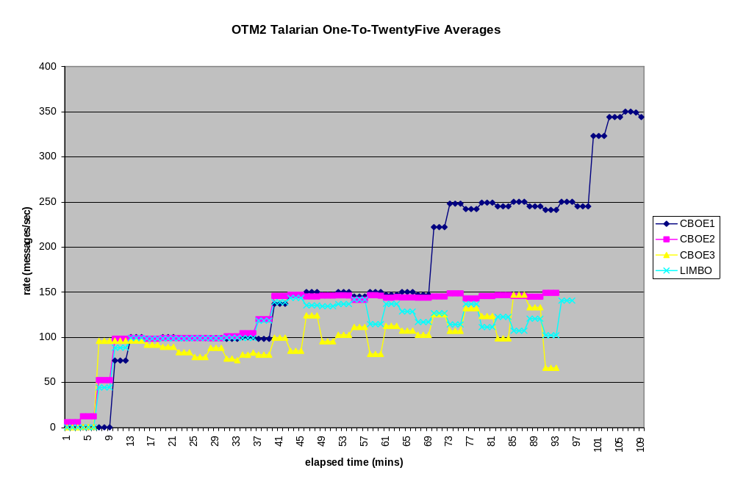 Figures 6 & 7. Talarian rates for OTM2 and OTM1
The results of the One-To-Twentyfive inter-box test for quote sized messages shown in the diagram above reveals some interesting information. The benchmark requirements place the minimum throughput rates for quotes at 150 msg/sec. The above test sustains a load of eight or nine JVM processes and one RTSERVER on each of the machines CBOE2, CBOE3, LIMBO. Of those machines, only CBOE2 was able to perform at the minimum required throughput although it was unable to exceed this level. Neither CBOE3 nor LIMBO were able to achieve the minimum throughput levels under this load.

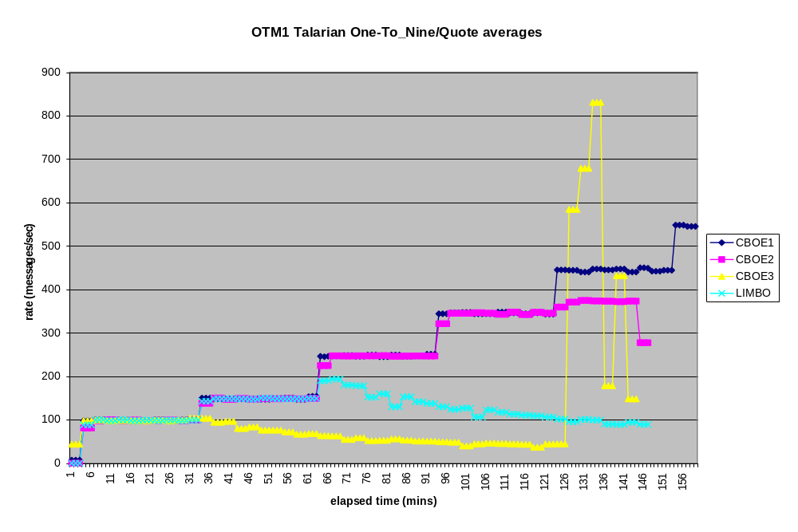
The results for the One-To-Nine inter box test for quotes shows better performance for CBOE2. CBOE2 can not only meet the minimum througput requirements for quotes, but exceeds them. However, it falls short of the maximum throughput requirement of 700 msg/sec. Neither CBOE3 nor LIMBO can sustain the minimum requirement consistently. The lighter load in this test, only 3 JVM processes and 1 RTSERVER, allows significantly better performance on CBOE2.

Other Results of Interest
The following section lists some remaining diagrams of interest.

OTM5
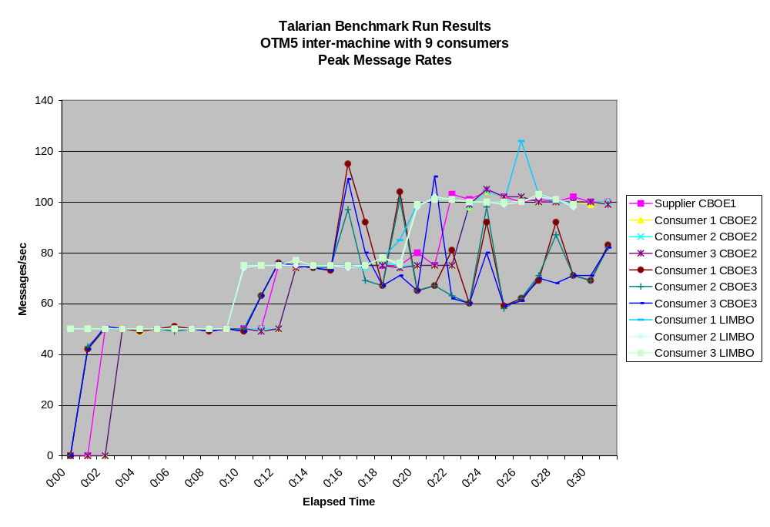
Figure 8 Talarian’s Peak Message Rates for OTM5 Inter-machine with 9 Consumers
The diagram in Figure shows that Talarian sustained message rates of up to 100 messages/sec with normal message delivery to nine consumers without any major problem. The only noticeable abnormality is the bounded throughput of CBOE3 at an average of about 80 messages/sec while the supplier is producing 100 messages/sec. This can be explained by the fact that CBOE3 is the slowest uniprocesor system used in the benchmark. This limitation should be considered while selecting the hardware for CBOE systems handling these volumes.

The tests for OTM5 show no difficulty on any machine of meeting the minimum requirements for throughtput of block messages (50 msg/sec). But CBOE3 could not approach the maximum throughput rates in the requirements (100 msg/sec).

OTM6

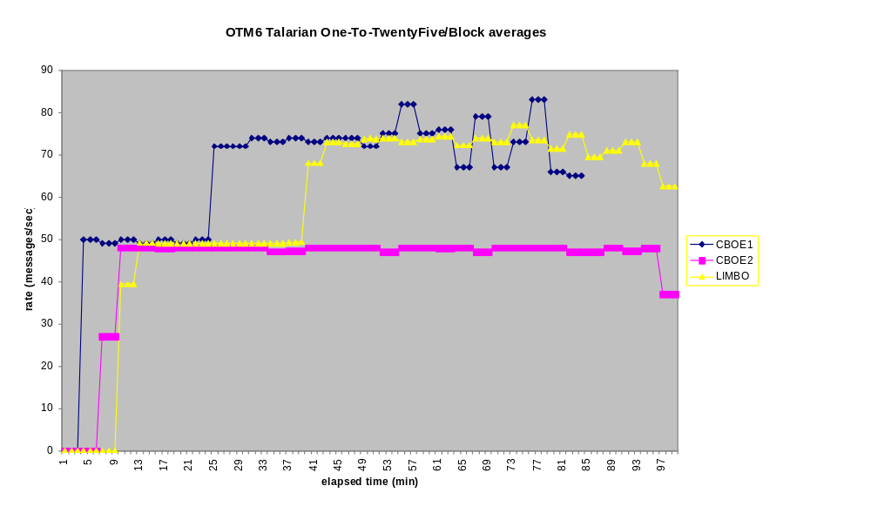
Figure 11 Talarian’s Peak Message Rates for OTM6 with One Supplier

The diagram in figure 11 shows the result of test OTM6 with one supplier and and average for all the consumers on Cboe2 and Limbo. It is interesting to note that the results in this test run contrary to the conclusion drawn in the scalability section of this document. Here the dual processor (2 X 168Mhz) Limbo, consistently out performs the single uniprocessor (275 Mhz) Cboe2. In general, this result is difficult to explain. The primary different between OTM6 and OTM1 & OTM2 is the larger message size and slower programmed rates. OTM6 used block size (8K) messages whereas OTM1 & OTM2 used quote size (50 bytes) messages. If the large message size somehow caused the Talarian product to introduce less serialization into the consumer threads, this might explain the results. However, no conclusions can be drawn without further experimentation. In general, the conclusion drawn for scalability remain unchanged. The OTM1 & OTM2 tests demonstrate that the RTCLIENT software can not be consistenly CPU scaled, and most of the CBOE traffic will be quote size messages. More experimentation might reveal a better hardware strategy. For instance, for quote based clients, faster uniprocessor machine may be more useful and for block based clients, dual machines may perform better. The situation, however, currently remains unclear.
STM1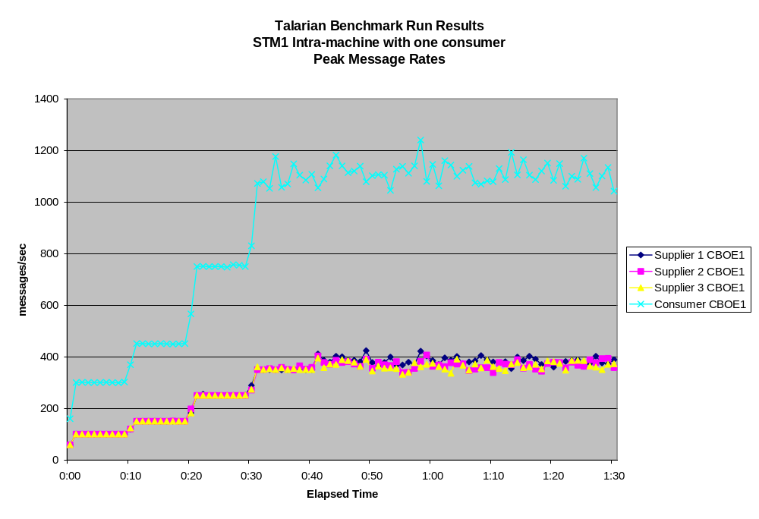
Figure 10 Talarian’s Peak Message Rates for STM1 with One Consumer
The diagram in Figure shows that the throughput of Talarian with three suppliers and one consumer in the same machine is bounded at an aggregate rate of 1100 messages/sec supplied. It is unclear whether the throughput is CPU, memory, or IO bound. To determine the cause it would be necessary to run the same scenario in the other machines and compare the results. It is also possible that, since the RTServer is single-threaded, its performance is limiting the overall throughput when running all the processes in the same machine.
It is interesting to note, that CBOE1 with a load of three supplier JVMs processes and one RTSERVER was able to meet and exceed the minimum throughput requirements for quotes of 150 msg/sec but fell short of reaching the maximum throughput target of 700 msg/sec. This is in contrast to tests, such as OTM2, with a load of only one supplier JVM process and 1 RTSERVER process on CBOE1, where there was no difficulty in exceeding the maximum throughput level of 700 msg/sec.

Impact of Java and JNI Layers on Throughput
It is not possible to guage the impact of the combined Java & JNI layers in any reliable fashion from the benchmark tests run. The team developed a control "MOM" library to supply artificial messages through the Java & JNI layers at CPU speed. This provided numbers for maximum throughput levels for an "ideal" MOM which consumed no CPU or IO resources. Comparing these numbers to the maximum throughput numbers of an actual MOM product would have allowed a comparison. Unfortunately, the benchmark tests themselves were not designed to run at maximum throughput levels and so no comparison is possible.
However, certain conclusions about the Java and JNI layers can be drawn from the behavior of the tests using control library.
First, there was a significant performance discrepancy between the message sending and message receiving sides in the combined Java and JNI layers.
For example, on the OTO1 scenario:
Receiver average max throughput 4912
Sender average max throughput 11887
This indicates that the overhead involved in receiving a message and passing it to the Java layer is too great. Observing the number of context switches taking place for receiving clients gives an average of 4 context switches per message. This could account for a large part of the performance difference.
Second, adding consumer clients to the same machine reduces performance of the Java/JNI layer. This may be due to the fact that each new client process requires a separate JVM and native interface. A 20% performance drop seems to exist between the one-to-one and the one-to-many scenarios as shown in the following table:
Number of Consumers | Per client throughput | Aggregate throughput
1 | 5000 msg/sec | 5000 msg/sec
3 | 1330 msg/sec | 3990 msg/sec
8 | 540 msg/sec | 4320 msg/sec

Regarding consumer-side performance, the native (C++) code used to implement the consumer-side connection experienced a very high number of context switchs per second. This is suspected to be due to the synchronization that was used around a queue within this layer. These context switches consumed the majority of time and are the cause of the drop-off in the aggregate rate of multiple processes. The result is that the consumers were CPU bound at much lower rates than suppliers, probably caused by a difference in the thread library threads created by the Java VM and the bound threads created in the native messaging library. Team members believe to know how to eliminate the context switches to bring up the consumers to an equivalent level with the suppliers.
The following changes to benchmark test configurations would better help assess the impact of the Java/JNI layers:
- Most benchmark tests would be run at maximum throughput. These numbers could then be compared to the number obtained from the dummy MOM tests. With these two numbers, we could estimate the percentage of time spent servicing the Java/JNI calls versus the time spent servicing the MOM. In the current set of tests, all of the tests throttled throughput, making impossible to tell when maximum throughput was encountered on the consumer side.
- A parallel set of C++ clients would be created. Comparing the measurements between the two sets of clients would allow an assessment of the relative performance impact of using Java. In the current set of tests, there were no C++ clients.
- Since the machines used in the benchmark were not identical, some tests would have be duplicated on different machine. For instance, the tests would appear in sets so that the suppliers would operate on the dual processor machines for one test in the set and on a uniprocessor for the other. Similarly the one-to-one tests and the one-to-many tests would be run on both the uni-processor as well as the dual processor machine. This would allow data to be compared on the same machine rather than across machine.

Summary and Conclusions
1. Talarian demonstrated better throughput during the benchmark runs than the other tested MOM products. However, stability problems with the other products prevented much progress from being made on running the planned tests. Talarian also exhibited stability problems, but timely feedback and assistance from Talarian support aloowed us to progress much further in the tests than with the other products. A summary of the stability problems involving Talarian is summarized below.
2. The disconnection of consumer clients (Talarian error code 10, 512). During the higher order tests, those utilizing multiple consumer clients per machine, we consistently experienced disconnects of the consumers during attempted runs of the tests, producing Talarian error code 10 or 512. The reasons received from Talarian for these disconnects form an acceptable explanation. When running the higher order tests, the consumer side clients are running CPU bound which means that the rtserver is capable of delivering messages faster than the consumers can receive them. Because of this, the consumer buffers in the rtserver eventually fill up and can not accommodate any more incoming messages. When this occurs, there are two possibilities in Talarian. Either disconnect the slow consumer-side client, or establish flow control and slow down the supplier. Talarian's default behavior is to disconnect the consumer. The alternative, establishing flow control, should be possible using Talarian's monitor API. However, this was not explored during the benchmarking tests.
3. The disconnects between rtservers and the reporting of inconsistent connectivity patterns through rtmon. This issue is not entirely understood, and there has not yet been an explanation from Talarian. However, it is not an entirely mysterious phenomenon. RTSERVERS maintain connectivity between themselves through the use of UDP broadcasts. UDP is a protocol which does not guarantee delivery of packets. It is not unreasonable to suppose that during periods of high network activity, as in the high-order tests, some of the UDP packets do not arrive at their destination. It is not hard to envision a situation where no two RTSERVERs received the same set of broadcast packets. What remains unanswered, is why the RTSERVERs do not re-establish proper connectivity once the network quiets and what the effect on message delivery might be when RTSERVERs do not consistently agree on connectivity patterns.
4. It appears that CPU scalability can not be effectively implemented in rtclients using the current version of Talarian. It may be more effective to utilize faster uniprocessor systems than slower multiprocessor systems. As new versions of Talarian become available, especially multithreaded ones, this issue bears re-examination. Additionally, only one threading model was tried. It may be worth the effort to experiment with other models to see if the CPU scalability of rtclients is improved.

Remarks

i. (Chuck) I wonder if they took the default values for buffer sizes (assuming this is a configurable parameter; I didn't see anything in the Talarian User Guide to do this). They could have tried to estimate the max arrival vs. consumption rates and come up with a buffer size that would have held through the majority of cases.
Only the default buffer size(10MB per RTSERVER) was utilized. The buffer size can be changed by setting CLIENT_MAX_BUFFER in the rtserver.cm file. Raising the buffer size would not have improved throughput rates but would have allowed RTCLIENTS to run at slower rates for a longer period of time.

ii. (Chuck) I don't know that a pure C++ test would be worth the time. Since we're still going with Java at this point, there's got to be a Java interface somewhere. Perhaps Peter's motivation is that he still believes Java will not work.
I agree with Kevin's & Paul's initial remarks: if we getting the desired throughput at acceptable CPU utilization, then who cares about the overhead of Java vs C++? Looking forward, I guess we should also ensure that these tests include projected quote rates due to decimals, etc.
Depending on CPU configuration and load, some of the tests met throughput requirements and some did not. For example, in test OTM1 having a load of three JVM processes and 1 RTSERVER per consumer host machine, CBOE2 had no problem meeting the minimum throughput requirements (150 msg/sec) but topped out at just less than 400 msg/sec falling somewhat short of the maximum rate goal of 700. Both CBOE3 and LIMBO could not consistently meet the minimum throughput requirements. In test OTM2, having a load of 8-9 JVM processes and 1 RTSERVER per consumer host machine, CBOE2 could meet, but not exceed the minimum throughput requirements of 150 msg/sec. Neither Limbo nor CBOE3 could meet the minimum requirements for throughput.

iii.(Kevin) The commentary at the end concerning Java / JNI is the same verbiage that Peter sent before - no changes. I thought many of us responded to this and from that modifications could be made.... Also, I thought of one other specific issue with that section. There are two paragraphs explaining the consumer side performance problems, postulating different explanations. I would remove the first in favor of the second (which talks about the threading and locking issues that were found) - unless I am misunderstanding what's being said there.
Both cases, the accumulation of JVM processes and the choice of threading model would seem to contribute to the degredation in consumer performance. In the multi-consumer case, the CPU power must be divided among multiple JVMs.

iv. (Kevin) It would still be nice to get an explanation for the rtserver connectivity / consistency problem...

There is still no explanation available from Talarian, but a plausible explanation is provided in item 3 in the Summary and Conclusion section.

3) It sounds, as somewhat expected, that the Java / JNI issue is not really a Java / JNI issue at all, except for some type of threading implementation difference in relation to the locking mechanism being used - which I would like to know more about. It would be good to rerun (at least some of) the benchmark tests using the fixed code. I don't think that we should replace all of the test scenarios with max-throughput type tests, but we could add a few that are like that. I think that there is some benefit to doing this in order to get some gauge on the MOM overhead. Also, even though I am curious about a C++ comparison, I don't think that doing one is of value right now. The important thing is to fix the C++ / JNI code and verify that the supplier vs. consumer differences (all but) disappear, and that the throughput reaches our desired levels. Lastly, I'm not sure I understand his box-difference item at the end of the message..?

Recommend re-examination of consumer performance after dispatcher threading model is changed or eliminated.

In practice it would be near impossible to apply Amdahl’s law numerically. At the very least, the unpredictable serial percentage introduced by context switching would be impossible to account for.

